Blundell’s fsl
Presents a
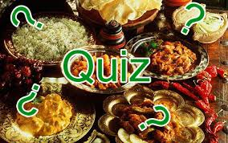

Curry and Quiz Night
Two Course Hot Buffet + puppodums etc
Saturday 15th August 2015
From 7:30 pm
£15 per person
Entry includes Quiz Sheet
Free Dinner for Couple with highest score
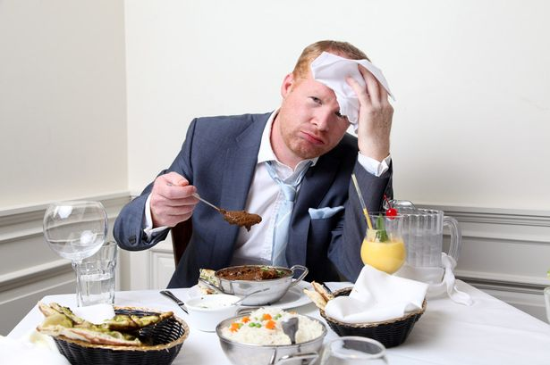

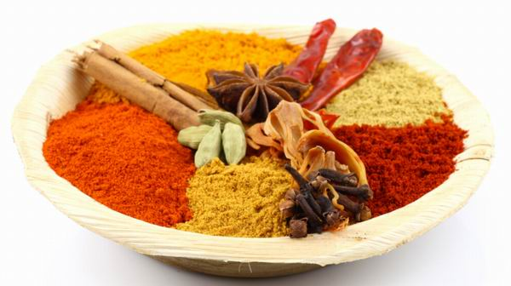
Advance bookings only – see staff for details

