21st January 2023

H.M. King Charles III – Coronation Celebrations

Dear Group Leader / Chair,

Firstly, apologies for the tardiness of my communication regarding the above.

Unfortunately, circumstances make it impossible to go ahead with the plan that we discussed. This is due to costs which have proved to be far, far higher than we anticipated. This coupled with the lack of interest from many organisation within our community have led us to abandon the plan.

We hope that you will all celebrate this significant event within your own groups and within your families.

Many thanks for your involvement, and we hope to see you at the Biggin Hill Carnival on Saturday 1st July!

Best wishes:-
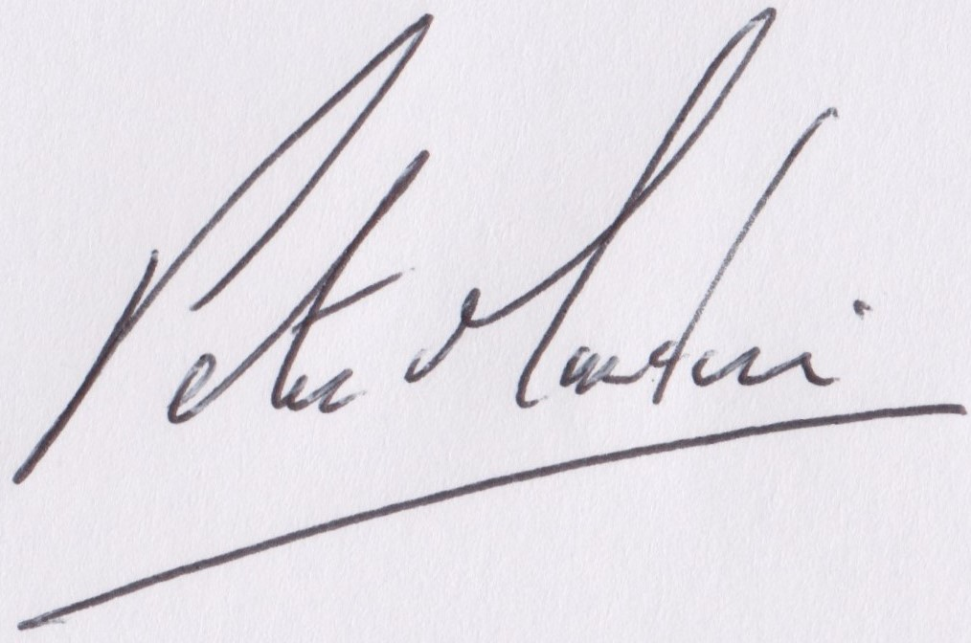
Peter Martin
Chairman
Biggin Hill Residents’ Association

