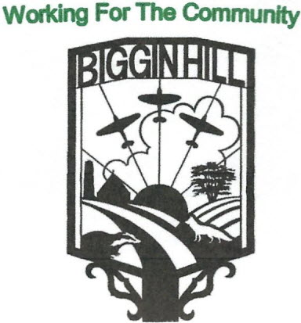
Biggin Hill Residents Association
Founded in 1934
www.bigginhillresidentsassociation.com

Date | Monday 13th November 2023
Location | Blundell’s Biggin Hill
Those present:, Graham Savage, Peter Martin, Rosemary Charleton,, David Haslam,, Kim Cross, Michael Saxon,, Luan Annaford, Ian Ramage,Melanie Stevens, Simon Turner

Agenda Item |  | Action | Person responsible
1 | To Open the Meeting | Peter opened the meeting and moved straight on to the matters outlined below | Peter
2 | Apologies | Apologies were received from Julian Benington. Tony Scullion  Stephanie Butcher, Sophie Dunbar and Adam Richards were absent
3 | Minutes of the meeting held on the 17th July 2023 | David wished to point out that his meeting, listed under AOB in the previous minutes, was in fact with the Borough Chairs of the Safer Neighbourhood Panel and was held at Bromley Police Station. Subject to this amendment, the minutes were agreed as follows:  Proposed: Peter Martin  Seconded: Luan Hannaford  Passed: All
4 | Financial Report | In Tony’s absence, Peter passed a cheque for £1,091.95 to Melanie for the sale of poppies.  Receipts for October were £1,056.88, of which the majority were for poppies (£794.74), and expenses were £1,056.88, of which the main ones were £66.53 for whiskey glasses, £150.00 deposit for the St. Patrick’s day band, AGM expenses, and a donation to St. Mark’s of £100, leaving a closing balance of £2,923.84 | Tony
5 | Pantomime | The arrangements for this are now well underway. Kim requested £150 for expenses. Only primary school children will get a present, without exceptions. At present ticket sales are 50 for Saturday and 2 for Friday. There was some discussion over whether carers should pay and it was agreed carers should pay half price, on a 1-1 basis. It was also agreed that 2 pairs of tickets should be offered to the Chronicle. | Kim
6 | IT Update | Ian and Luan held a meeting concerning revamping the website Homepage which will have 5 areas – a mission statement, a history of Biggin Hill, news, gallery and a calendar of events. The colours will be in red and blue to reflect the RAF, but not green.  Graham gave Ian coloured font examples. Luan wants the 5 Biggin Hill signs cleaned before photographing them. Peter agreed. | Ian, Luan, Peter
7 | Publicity | Luan wants guidance on what we are advertising (and what not). Basically, anything not profit-making and for the community, with an urge to people to contact BHRA if they are doing an event. The Newsletter will contain events in Biggin Hill .  David will copy his History of Biggin Hill to Luan in chapters.  Regarding finance, there is a website domain of £10 p.a., and we will continue with this.  The Mailchimp will be handled by Luan and Peter once they have authorised access.  Peter wants to send out information on BHRA by email. Luan and Ian will sort this. | Luan, David, Ian, Peter
8 | St Patrick’s Events | Lynne produced a summary of progress to date.  The event will be held on the 16th March at 7 for 7.30pm. The band is D’Arcy Spice costing £650 (a deposit of £150 has been paid, with the balance paid on receipt of invoice). They will play for 4 hours. The meal will be 2 courses, Irish stew, or a vegetarian option, and Irish apple cake, with free meals for helpers. Irish liqueur is optional and coffee and soft drinks will be available. St Mark’s and the Squash Club will sell the tickets (cash only). Graham will print the tickets, which should also mention the byo drinks and glasses.  There will be more publicity after the panto, and a subcommittee was suggested. | Lynne, Kim Graham
9 | Social Events | A quiz has already been agreed for the 24th February. Other suggestions were a business-style Bunny hunt for shops ( an Easter treasure hunt with a difference) and a walking treasure hunt.
10 | Requests for Funding | There has been a request from the new football club, who have received a grant from the airport. The lease is £900 until May, and we agreed to pay 50%, i.e. £450. Proposed: Peter, Seconded David, passed: All.  Luan had a letter from the Factory shop and the Sweet shop, offering to let us share the profits. It was agreed this is not one for us and suggested they approach local charities such as Community Care or Westerham food bank. | Luan  David Peter
11 | A.O.B. | There were thanks from Peter for the poppy set-up. The poppies will be taken down this weekend | Peter

Dates of next Meeting: (all at Blundell’s starting at 7.30pm): 18th December 2023. This is social only, starting at 7pm.

The next full meeting will be on the 15th January 2024 at 7.30pm.

