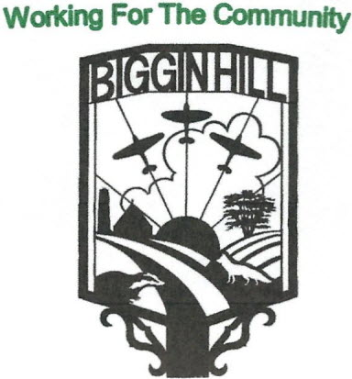

Biggin Hill Residents Association

Founded in 1934

[www.bigginhillresidentsassociation.com](http://www.bigginhillresidentsassociation.com/)

AGM

|  |  |  |
| --- | --- | --- |
| **Date** | Monday 21st October 2024 |  |
| Location | New Life Church Biggin Hill |  |
| Those present:, Peter Martin, Rosemary Charleton, David Haslam,, Kim Cross, Simon Turner,, Melanie Stevens, Ian Ramage, Sophie Dunbar, Taylor Morris, Fred Saxon, Annee Webb |  | |

|  |  |  |  |
| --- | --- | --- | --- |
| Agenda Item | | Action | Person responsible |
| 1 | **To Receive the minutes of the AGM October 2023** | The chairman, Peter Martin, asked for comments.  The minutes were:  Proposed: Melanie Stevens  Seconded: Lynne Martin  Passed: All | Peter |
| 2 | **To Receive the Chairman’s Annual Report** | Peter reported on what he described as another memorable year. This included matters outside our immediate control (issues raised by Bromley Council and the London Mayor), but where problems were minimised as far as possible by our Councillors. Financially it has been a good year (see the Treasurer’s report for details), but we would still like more members.  Peter outlined the forthcoming social events and concluded by requesting a volunteer for the computer database and the Mailchimp section.  We then moved on to the the presentation of the Bob Shekyls award. There were 2 winners this year, but unfortunately neither were present – Tom Halliday from the football club, Bob Marshall received his award from Melanie, and Luke Bachelor..  There was also a presentation for the 2 winners of the shopping bag competition – Corben Russell in the younger age group, who was not present, and Nate Newberry, whose award was presented by Sophie. | Peter |
| 3 | **Treasurer’s Report** | The Treasurer was unable to be present, but provided a spreadsheet, showing that the total income for the year was £8,366.29, and the expenditure was £6,593.92, giving a profit of £1,772.37. The income came from merchandise sales, membership fees and the majority from social events- these events generated a surplus of £3,370 after costs. The “sponsor a poppy” campaign raised £1,092; Biggin Hill airport contributed £546 towards replacement defibrillator batteries, and we received £450 from RLR Goldsmith for litter picking work.  The main expenditure items were the Poppy Appeal (£1,092), St Marks Church lighting fund (£1,100), 3 defibrillator batteries £536), Biggin Hill FC £(801), Air Cadets building repair (£500) and new banners for the Safer Neighbourhood team (£236).  The accounts were audited by Peter Cureton-Jones.  Peter finished by asking for funding requests. | Tony |
| 4 | **Chairman’s Vote of Thanks to the outgoing Committee** | Peter duly thanked the outgoing committee for their efforts | Peter |
| **5** | **To Elect a Chairman, vice- Chairman and other committee members** | David took this section and thanked Peter for all his work. The existing committee were duly re-elected as follows:  Proposed:David  Seconded: Lynne  Passed: All | David |
| **6** | **To Introduce tonight’s Speakers** | There were 3 speakers listed. Mr Andy Furphy from the Biggin Hill FC was not there, Flying Officer Rachel Coyle of the Biggin Hill Air Cadets,(who has only been in post for 10 weeks) gave a short speech which concentrated on the recent redecoration, and local author Peter Osborne, a resident of 44 years, who gave a comprehensive account of the airport’s history. | Peter |
| **8** | **To Close the Meeting** | Peter thanked everybody for coming and closed the meeting | Peter |

**Date of next AGM October 2024**