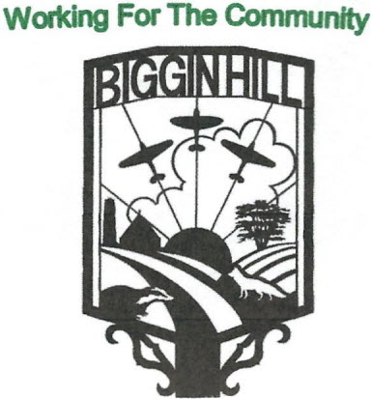
Biggin Hill Residents Association
Founded in 1934
www.bigginhillresidentsassociation.com

Date | Monday 14th July 2025
Location | Blundell’s Biggin Hill
Those present: Rosemary Charleton, , Kim Cross, Fred Saxon,Peter Martin, David Haslam, Annie Webb, Ian Ramage, Luan Hannaford, Tony Scullion

Agenda Item |  | Action | Person responsible
1 | To Open the Meeting | Peter opened the meeting by welcoming those present, and moved on swiftly to the rest of the Agenda. | Peter
2 | Apologies | Apologies were received from Sophie Dunbar and Melanie Stevens  Simon Turner was absent
3 | Minutes of the meeting held on the 12th May 2025 | The minutes of the meeting held in June were agreed as follows:  Proposed: David  Seconded: Luan  Passed: all
4 | Financial Report | Tony had provided his usual spreadsheet for June, which showed receipts of £82.00, mostly membership fees, and payments of £581.40, which consisted mainly of £366.68 for a gazebo cover, £32.99 for a tablecloth, £100 donation to the Spitfire project & Carnival advert, and £39.95 presentation plaque for Alison Newman.  The opening balance was £2,203.95, and the closing balance was £1,704.55, with total funds available of £1,822.30  Peter is hopeful of getting some Carnival funds.  Thanks to Tony | Tony
6 | Spitfire Community Project | The current situation is that the Council has suggested that the only way for us to retain the centre is to purchase it, at approximately £800,000.  There is nothing for BHRA to do at the moment. | Peter, Annie
7 | Publicity/I.T. | The next meeting of the Moving Church News is due on the 18th July. Luan will mention the Choi Pin, the Teddy Bears picnic and the St George’s Day event. The next item will be a poster for the Disco Bingo.  Ian has sorted out the website issues, which is now online, and has ownership of the domain, hosting and email etc on one account.  An issue arose concerning the BHRA Logo/badge, which is not trade marked. We need to get this sorted before inviting people to the meetings who might want to set up in opposition. David has a previous article on this subject which he will resurrect, and Annie will take on the trade marking | Luan, Ian
8 | Biggin Hill Carnival | The carnival was a good shop window and raised £66. Next year we should have a double site | Peter, Annie, Fred
9 | Social Events, Feedback & Future events | The Choi Pin meal, organised by Annie, was a great success, with positive feedback, although too noisy. Choi Pin will give us a financial cut.  Future events suggested were a Pizza night at the Bakery in Tatsfield, possibly on the 17th October. Annie suggested a Jazz band for £400 (at the Spitfire?), possibly January or February, or maybe somewhere on the airport (hangar or Bombardier).  Also suggested was a family Xmas breakfast, possibly at the Kings Arms for the 29th November (we should make sure there are no clashes with the Lookout café)..  Sophie had sent a letter regarding a fundraising community football event, to take place at the end of August. If we help, the award should be in our name. Kim, Luan and Annie will set up a meeting with Luke, and Luan will tell Sophie | Peter, Kim, Annie, Luan
10 | Poppies | Poppies will be sold on the 11th & 18th October, and the date for putting up the poppies is 1st& 2nd November. | Peter, Fred
11 | AGM & A.O.B. | Regarding speakers, David Winstanley from the airport has been asked, and Peter also suggested Mr Lockier from the airport.  Bob Shekyll’s award – Luan suggested opening it up to older people (there are no candidates yet). Peter will ask Geoff Ghostt about this, and wondered if Mrs Shekylls is still alive to consult.  David Dilling is concerned re data protection of members details. David Haslam will ask him to join in to look after this aspect. | Peter  David

Date of next Meeting: (all at Blundell’s starting at 7.30pm): Monday 8th September 2025. There is no meeting in August.

