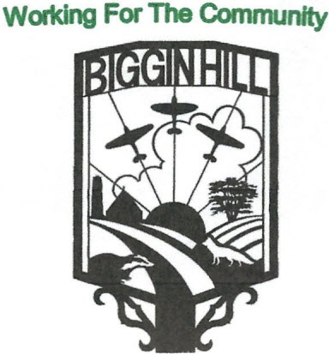
Biggin Hill Residents Association
Founded in 1934
www.bigginhillresidentsassociation.com

Date | Thursday 16th October 2025
Location | Blundell’s Biggin Hill
Those present: Rosemary Charleton, Fred Saxon,Peter Martin, Annie Webb, Tony Scullion, Melanie Stevens, Stephanie Butcher

Agenda Item |  | Action | Person responsible
1 | To Open the Meeting | Peter opened the meeting by praising the AGM, and in particular the excellent speakers and mentioned that the cheese and wine is a good way of getting to know people. The raffle was suggested by David Winstanley from the Airport. | Peter
2 | Apologies | Apologies were received from Ian Ramage, Kim Cross, Sophie Dunbar, Mikoi Hersey, David Hallam and Luan Hannaford.
3 | Minutes of the meeting held on the 12th May 2025 | The minutes of the meeting held in September were agreed as follows:  Proposed: Annie  Seconded: Tony  Passed: all
4 | Financial Report | Tony produced his usual spreadsheet, which revealed September to have been a quiet month – total receipts were £537.00, an payments were a small amount of £2.16 to PayPal, leaving total funds available of £2,414.99.  Upcoming commitments are:  Balance on the Disco Bingo £200, Shekyls Award £100,The Christmas draw £100, Christmas Lights Sponsorship £200 and Website costs £110.  Tony is to chase the Friend of the Park regarding their recent request.  Thanks to Tony. | Tony
6 | Requests for Funding | Peter has received several requests for funding –  Tony Lewis (a local author doing a sequel to Grandfather’s Biggin Hill) is seeking assistance. Peter agreed to ask Tony what he is thinking and £100 was suggested.  Stephanie Butcher came to talk about defibrillators. We currently have 3 operational ones and 1 spare. One older one has died. It costs £1250 to replace one, so we need to build up a war chest and we should use fund raising activities for this, starting with the raffle on the 17th at the Bakery.  There was a 3rd request from Jan Chart of Westerham u3a for funding for BSL (British Sign Language). It was felt that any support from BHRA should be dependent on the site used being within Biggin Hill, and that BHRA’s main funding should be for the defibrillators. | Peter  Steph-  annie
7 | Publicity/I.T. | Neither Luan nor Ian were present, so this section was omitted. | Luan, Ian
8 | Poppies | Last Saturday’s sales raised £305, and BHRA will be selling poppies again this Saturday (18th). Fred is organising the installation of the poppies and will know by this weekend how many poppies and cable ties will be required. Poppies are put up on the 25th October and have to be down by the 22nd November | Peter, Fred
9 | Spitfire Community Projcet | There was an extremely successful meeting with Bromley Council on the 13th October when the B/H petition was presented, and unanimously passed. Biggin Hill now has a year to raise the funds to buy the site. | Peter, Annie, David
10 | Social Events – Feedback & Future Events | The Italian evening at The Bakery in Tatsfield is now fully organised, with 52 people coming on the 17th October.  The Thai meal at the Choi Pin is at the end of November, and Peter floated the idea of a Murder/Mystery evening in February.  We are still selling merchandise which is now with Tony. | Peter  Annie
11 | A.O.B | Melanie is running the draw at the Lights On show.  Santa’s Sleigh will take place on the 19th & 22nd December.  Melanie is organising the funds for the Biggin Hill Church Road playground. | Melanie Peter

Date of next Meeting: (all at Blundell’s starting at 7.30pm): Monday 10th November 2025.

