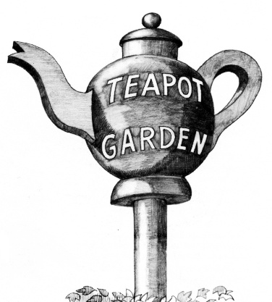
Picture by Ken Wilson
The Teapot Garden
One of the attractions, which brought people from all directions on their bikes, in the early days of Biggin Hill was the plethora of tearooms that were scattered around. The most famous of these was ‘The Teapot Garden’ and the huge wooden teapot that was located near the road, on a large pole, that advertised the tearoom.

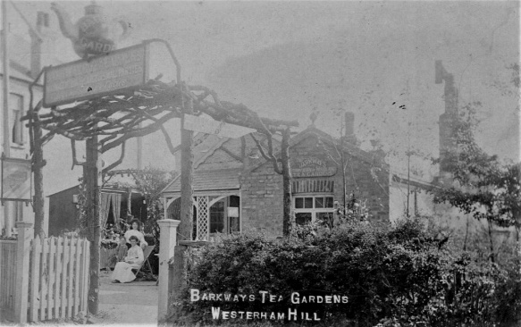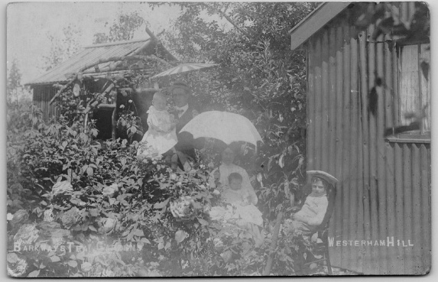
This picture shows the original Tea Gardens owned by William Barkway which has the wooden teapot above the entrance to the garden. The location of this tea garden is easy to find, not Westerham Hill as stated on the postcard, as the building on the far left, the side of which can be seen, was a building that fronted on to Main Road and became the retail shop of Abbotts the bakers (later still it would be the Biggin Hill ‘GAS Centre’).

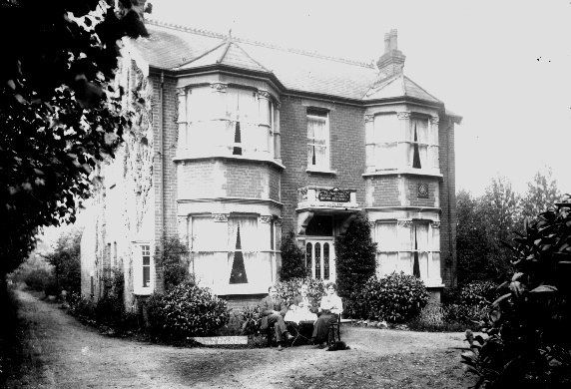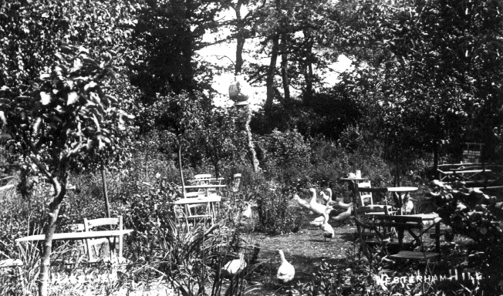
Around 1915 the tea gardens were acquired by a Belgian, Alphonse Haentjens, but soon the popularity of cycling meant that the premises were inadequate to cater for the number of cyclists coming out to Biggin Hill from South London on weekends. Haentjens then moved the business a hundred yards or so in the direction of Westerham to “Highclere” a much more substantial house, taking the big tea-pot with him and erecting it in the large garden, also fronting on to the Main Road.
During the First and Second World Wars, units stationed at the airfield would carry out 'moonlight raids', removing the teapot from its pole and bringing it back to the airfield. It was soon returned only to be stolen again the following night by another unit.
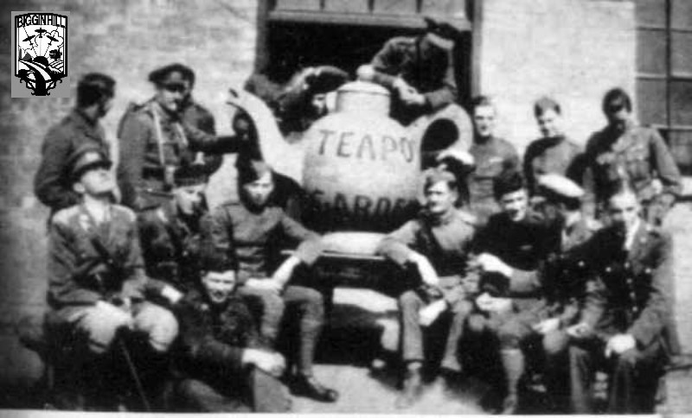

Operation Teapot
Over the generations, in the vicinity of Biggin Hill, there lurked groups of mischievous young men who saw the teapot as a challenging ‘Prize’ to be had at all costs. These shadowy, nefarious people, which included Biggin Hill’s World War One Royal Flying Corps, World War Two RAF fighter pilots and an insignificant group of 1961 government engineering apprentices. These apprentices lived some 7 miles away at an apprentice hostel at ‘Coed Bel’, Lubbock Road, Chislehurst and it was here that the teapot was to spend a few of its days in ‘protective custody’.

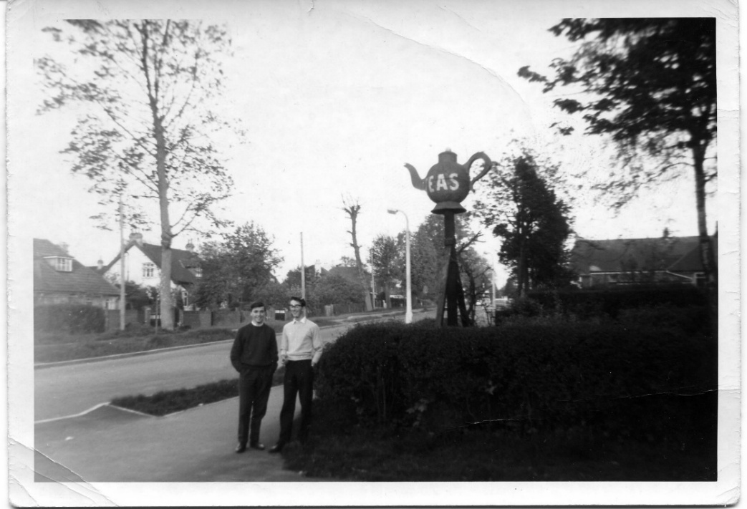

On Friday, 21st, April, 1961 Stan, Pete, Mick & Olly paid a visit to the teapot to photograph it in situ before its disappearance some 6 hours later. This enabled them to observe that the teapot was bolted to the top of the pedestal - little obstacle for engineering apprentices to overcome. Under cover of darkness they returned, climbed the pedestal, swiftly unscrewed the bolts, placed the teapot in the back of Pete Hing’s van and promptly made off with it to Coed Bel.

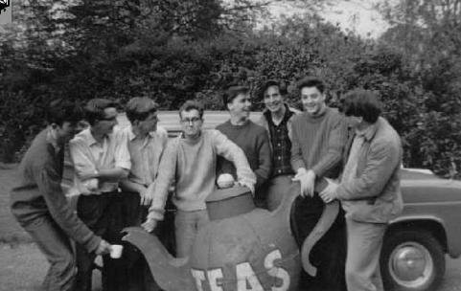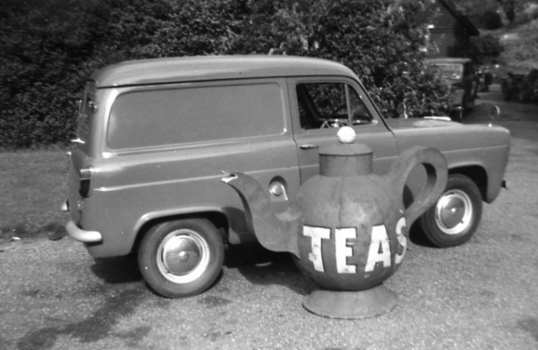
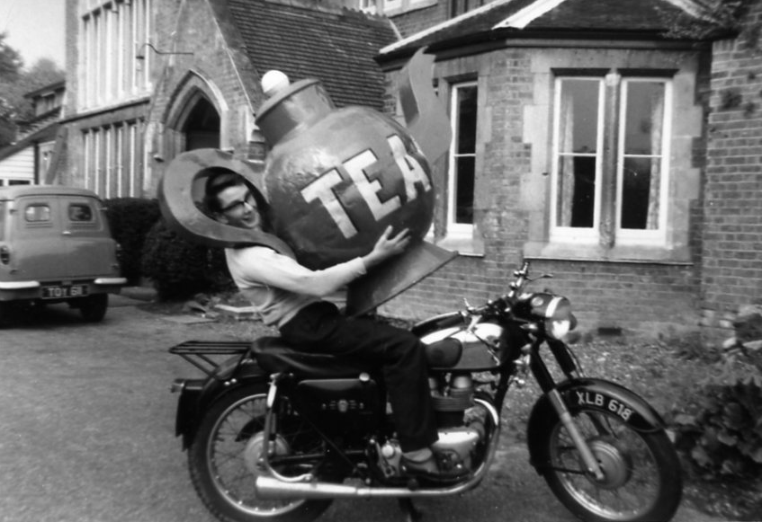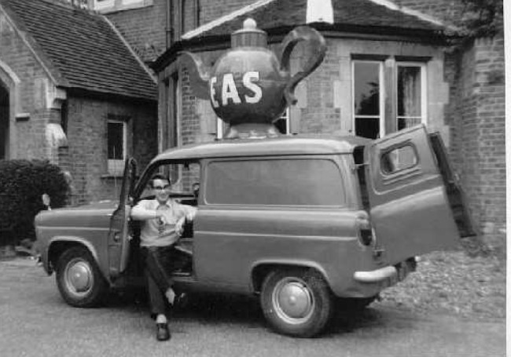
First image (from left to right) Olly Hulf (conspirator), Pete Hing (conspirator), Patrick 'Paddy' Parry, Clive Tattersall, Mick Belcher (conspirator), Stan Weeks (conspirator), 'Gos' Gausby & Barry Martin.
It was never intended to permanently deprive the owners of their teapot. The objective was to borrow it, re-paint it, photograph it and then return it. The teapot was re-united with its owner within days and Stan Weeks personally apologised to them for anxiety and inconvenience caused. He explained that he had simply ‘borrowed’ the teapot for the sole purpose of associating himself with its fascinating history.

Finaly, someone we all know very well. John Nelson stands in his front garden next to his ‘topiary’ teapot.
