BHRA ANNUAL GENERAL MEETING
NEWSLETTER
Hello Biggin Hill!
Welcome to our 2026 AGM and thank you for joining us in this our 92nd year!
This has been a year of change for the BHRA, including the appointment of a new Chair and Vice Chair and the addition of some new faces to the Committee! We are excited to have the opportunity to introduce ourselves this evening and to hear from our membership on how we can better support you.
But first we want to update all our friends and neighbours on what we have been up to this year….
The year started with the delivery of the ‘Save Our Spitfire’ Petition to LBB. Once again Biggin Hill showed us the true meaning of community spirit, by throwing your weight behind our petition to ‘Save Our Spitfire’ centre. With your help, the BHRA managed to raise 2435 signatures that were handed over to The Spitfire Community Project to deliver to the Council. Thank you to everyone that supported the petition and to the team at the Spitfire Community Project who worked so hard in helping to secure the Spitfire Centre for future generations. Thanks, must also go to Waitrose for letting us camp out on their doorstep for quite a few weekends, allowing us to collect all your signatures.
Not only have we been focused on community projects, but we have enjoyed hosting many fundraising events throughout the year. The first of which was a fabulous Italian evening at The Bakery in Tatsfield.
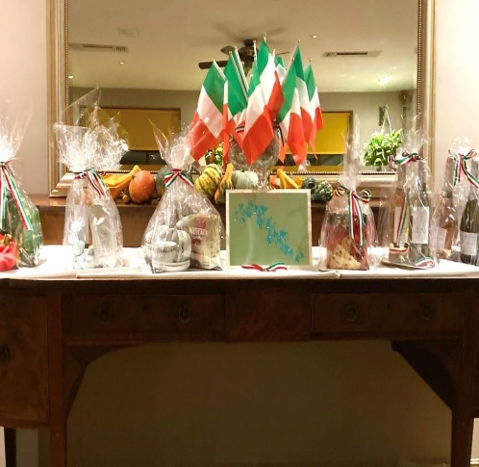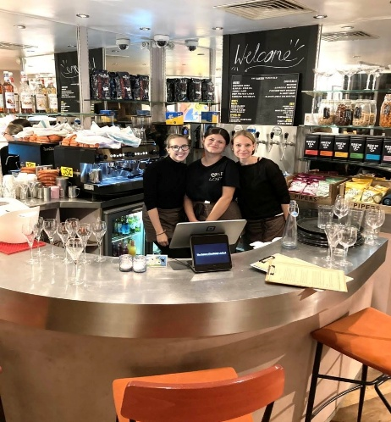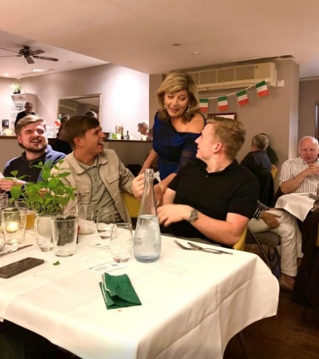

We were entertained with some live music and enjoyed a lovely 3 course meal, finishing the evening with a raffle which raised valuable funds for the Association.
Hot on the heels of our Italian evening came our Malaysian night held at Choi Pin….
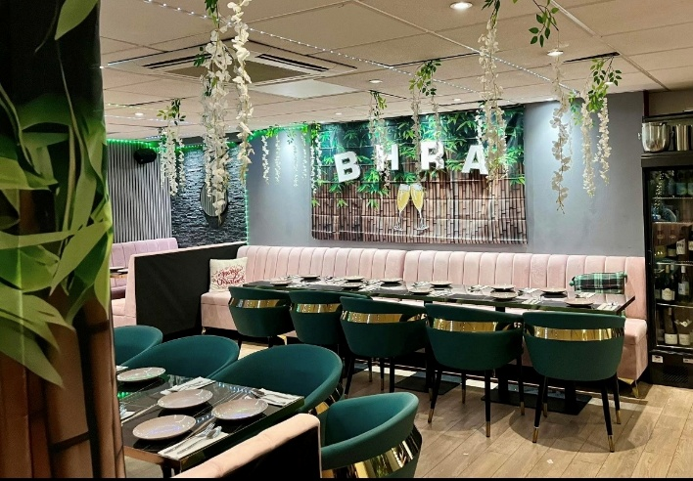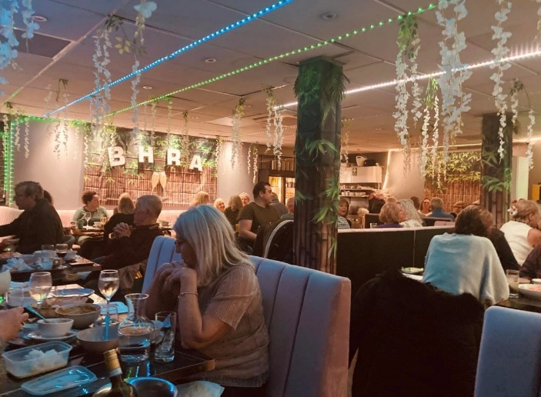
With some fabulous live music and a curated tasting menu of fragrant noodles and rich curries, it was truly a night to remember!
Every November the BHRA have the honour of adorning our village with Poppies. Each year we invite residents of Biggin Hill to sponsor a poppy for Remembrance. This year we raised a total of £775.18 for the Poppy Appeal. Thank you, Biggin Hill.
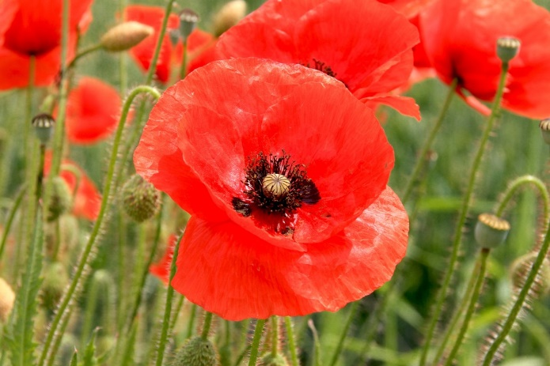

As Christmas was approaching, the BHRA turned their attention to causes further afield. Working with our local U3A, we sought to bring a little happiness to the children of Ukraine. With your generosity we were able to bring a bit of Xmas cheer to 58 young people in Ukraine.
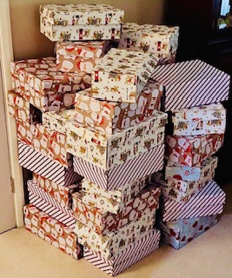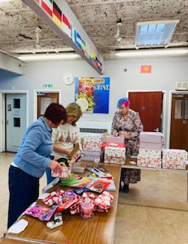
We were delighted to have been selected by Waitrose for their Green Token scheme this year and were over the moon to receive £500. The Committee agreed to contribute 50% of these funds to our new Planning Opposition Support Fund, launched this year……

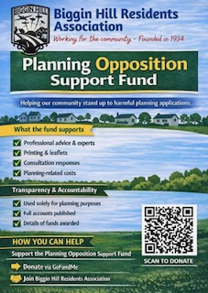
April saw us host this years 2026 Election Hustings at Oaklands School. The event was well attended by both residents and local candidates who took to the floor to answer your questions. It was a great evening with an opportunity to meet the candidates and discuss all the pressing issues impacting the lives of residents of Biggin Hill.

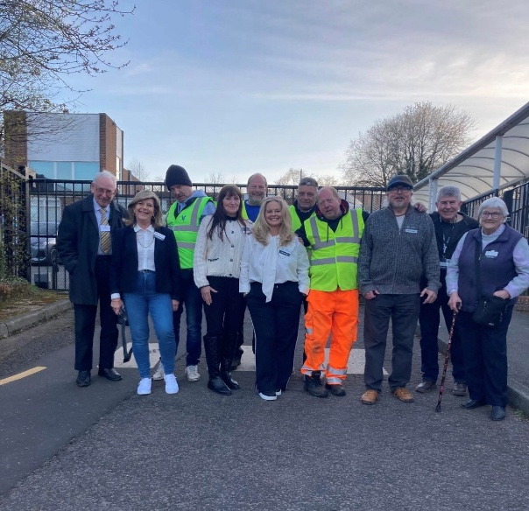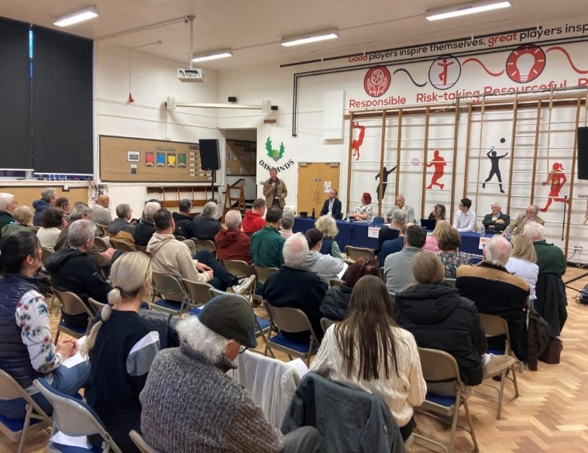
One thing that never falls off our ‘to do list’ at the BHRA is helping to keep our village clean and tidy! We haven’t been able to undertake as many litter picks as we would have liked this year, but we were out and about in April helping to keep Biggin Hill litter free. Watch this space for details of our next outing!
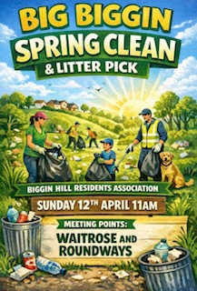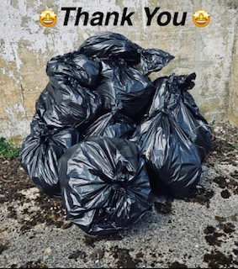
A new addition for us this year was the introduction of our Coffee & Catch ups with the Committee. We want to be as visible as possible and available to hear from our members and residents. Stay tuned for details of our next catch up!

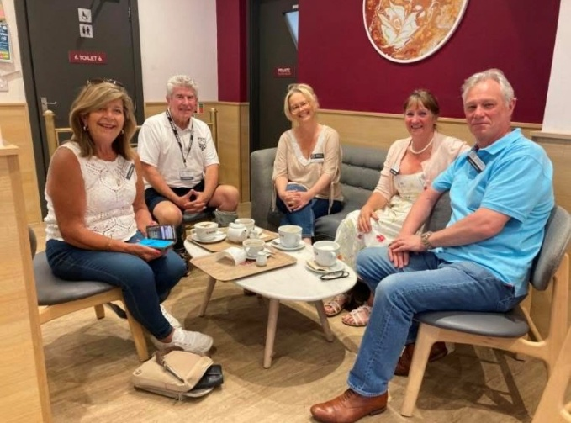
We are always looking for new and exciting events to entertain the widest of interests for our community. Enter a certain Miss Dolly Trolley and an evening of Drag Bingo! It was a great night full of laughter, great tunes and some spectacular tail feather shaking …. What a night!
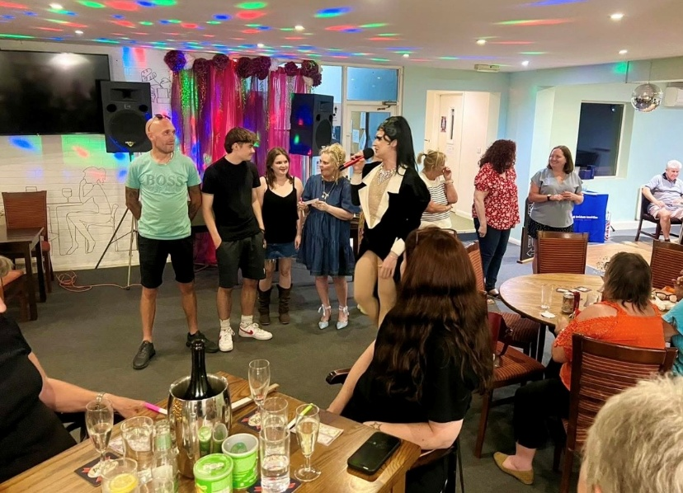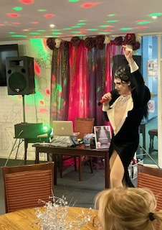
Another new venture for us this year was the introduction of our annual ‘Biggin in Bloom’ event. Working with other local groups and associations including Biggin Hill Horticultural Society, residents were invited to dust off their gardening gloves and submit their garden creations with a chance to win a voucher to Westerham Heights Garden Centre. All monies raised will be going towards improving the planters along our high street. Don’t forget to pop it in your diary for next spring!
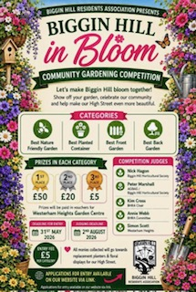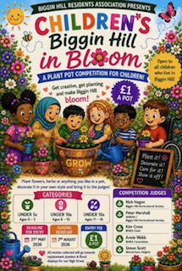
The summer wouldn’t be complete without our attendance at the annual Biggin Hill Carnival. What a scorcher of a day that was! Despite the weather curtailing some of the activities, a great day was had by all. Thanks must go to the Carnival Committee and all the volunteers for making such a wonderful day possible.

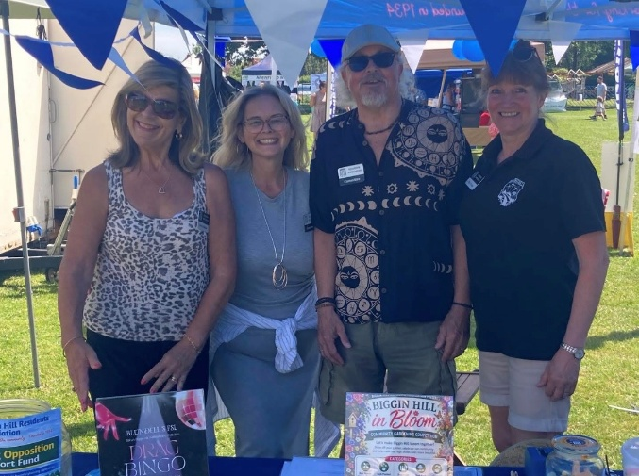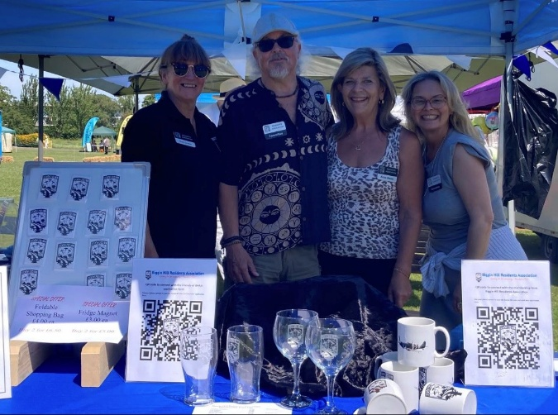
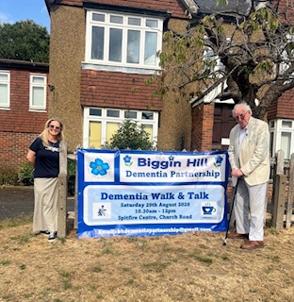
We were thrilled to be able to support the newly formed Biggin Hill Dementia Partnership this year with their very first Dementia Walk & Talk. The BHRA were able to donate some funds to support this new initiative and the turn out on the day was quite overwhelming in spite the August showers! It certainly highlighted the need for greater Dementia support within our village, and we look forward to seeing this initiative thrive.
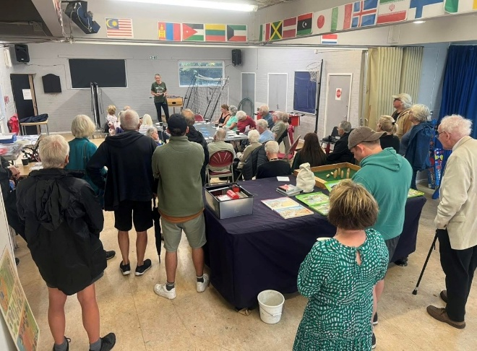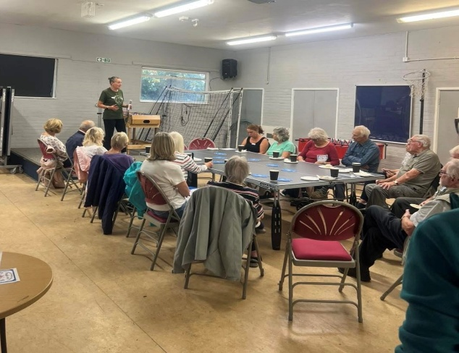
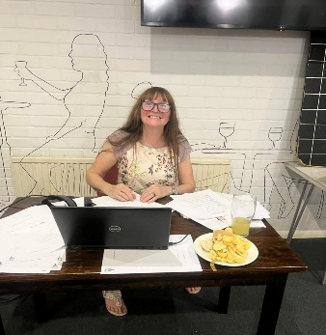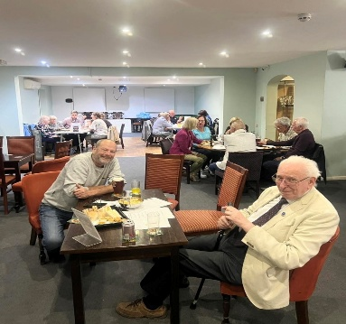
We had a quizzical kind of September when we were all put to the test by our new Chair Kim! A fantastic £160 was raised for the community. Thank you all

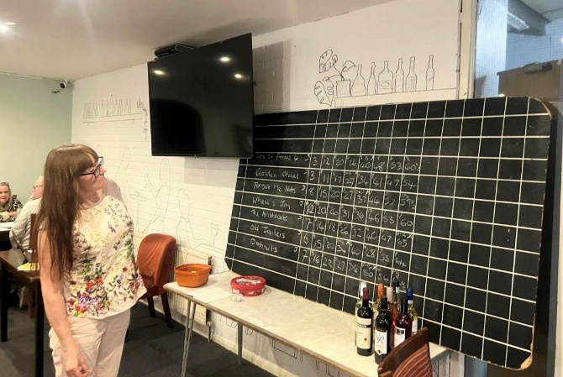
One of our more important actions is to help take care of what takes care of you… We are pleased to advise that we have secured further funding for the ongoing maintenance and installation of new defibrillators within the village. Thank you to the Kings Arms for their donation and to BHAL for their continued support. We couldn’t do this work without the dedication of Stephanie Butcher, thank you Steph! Further details of all locations can be found on our website, and we hope to bring you further news of additional defibrators coming to the valley in the near year.
On top of our wonderful fundraising events this year, we have been hard at work updating our membership processes. We have introduced a new online application form to make joining us even easier. All new members are now also invited along to a new members evening to meet the committee, find out about what we do and share what you would like from your BHRA!

Alongside our new membership process, we have a brand-new opportunity for our members. Why not become a ‘Friend of BHRA’? We heard loud and clear from our membership this year that you wanted an opportunity to get more involved with our activities. In becoming a ‘Friend’, you will be notified whenever the Committee need an extra pair of hands! Details are on our website so why not sign up today………

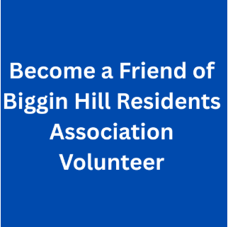
So why not get involved and join us for our next event? Be the change you want to see in your community…. Join your Biggin Hill Residents Association today!

Remembering our friend and colleague
Julian Bennington

Your BHRA Committee

Kim Cross - Chair Social / Fundraising / Events
I am a third-generation resident of Biggin Hill. I grew up on a local farm and helped on the family milk round from the mid-1960s. I have raised my family in Biggin Hill where my family built the local Biggin Hill Squash Club. I have worked there since 1981 before taking over as boss in 1994.
I believe in Biggin Hill as a community which is why I joined the Residents Association.
Luan Hannaford – Vice Chair Publicity / Communications
Biggin Hill has been home to my family since 2012 where I have raised my 3 children & work full time for a Dementia Charity. I have been supporting our Residents Association since 2023 with all things ‘publicity’ to help bring news & information to our community. I am also the secretary of the Biggin Hill Safe Neighbourhood panel and interim Chair of the newly formed Biggin Hill Dementia Partnership. I am passionate about working towards making Biggin Hill a Dementia Friendly village and am proud to be part of such a great committee. I enjoy working together to make our village such a great place to live. Why not ‘Join Us’ today!
Annie Webb – Secretary Events / Partner Liaison
I have been a resident in Biggin Hill for over 50 years and have seen many changes to our village and its amenities. Having recently retired, I now have more time to ‘give-back’ to the Community that’s given my family and I so much. I am interested in people, love animals and am passionate about the environment. I am member of Biggin Hill Horticultural Society & also the Biggin Hill Shedders. I enjoy keeping fit and can often be found each week at our local pool doing Aquafit.

Your BHRA Committee

David Haslam - Hon Life President Governance / Planning / SNP

Prior to retirement I ran my own architectural practice specialising in high end house design – 1983 – 2011.
I am an Honorary Life President of Biggin Hill Residents Association and current Chairman of Biggin Hill Safer Neighbourhood panel since 2017. I have raised my family in Biggin Hill and held many previous roles locally including:
- Councillor for Biggin Hill ward of LBB – 1978 – 1994.
- Governor and member of Charles Darwin Multi School Academy 1978 – 2024.
- Governor and Chairman – Oaklands Primary School 1978 – 2000.
- Governor and Chairman – Biggin Hill Primary School 1978 – 1994
- Member and Chairman of Biggin Hill Residents Association 1974 – 2014
- Director of Biggin Hill Airport Limited – approx. 1980 – 1994
- Chairman of Shadow Board of Biggin Hill Airport Limited – approx. 1992 – 1994
- Created Honorary Alderman of LBB – 2014.
Tony Scullion – Treasurer Membership / Merchandising
I have lived in Biggin Hill for over 30 years. When I saw that the Residents Association were looking for a new Treasurer in 2023, I decided to put my name forward, having recently retired. It’s been a pleasure to be involved with this organisation who are doing great things for the local community. Try it yourself!

Your BHRA Committee

Ian Ramage – Webmaster Events / Communications
Since I retired after many years of being Library IT Services Manager for Bromley Libraries, I have continued to design, build, and manage websites.
I also draw and sell pen and ink pointillist artwork from my studio in Biggin Hill, and am involved with several local community groups and events.

Fred Saxon – Committee Member Operations / Merchandising
My mum was born in Biggin Hill, and my dad was in the RAF resulting in a life of travel. I began helping at the Biggin Hill Squash Club in the late 90’s after visiting family and I am still here thanks to the Village spirit!

Bob Marshall – Committee Member Risk Management / Health & Safety / Defibs / Fire Marshal / First Aid
I moved to Biggin Hill in 1963 and can trace my family having lived in the surrounding area back to the 1720s. I have been aware of the good work the Association has done over the years and on seeing the Association was looking for new members I decided to sit in on a meeting in March 2026 and as a result decided to join.
Why not consider becoming a member of the BHRA Committee today?

